
BOISE CENTRAL DISTRICT
Urban Renewal District
TERMINATION 2018
The Boise Central District was Idaho’s first Urban Renewal District. When formed, it included ten struggling blocks in the heart of the city. The effort was a tremendous success with all parcels redeveloping into a safe, vibrant mix of commercial uses supporting and serving Idaho’s capitol city – the state’s center of commerce and government. CCDC won a national gold ‘Excellence in Economic Development’ award for its Central District work.
During its 30-year term (1989-2018):
- CCDC reinvested $61 million of tax increment revenue into revitalizing the district.
- An enriched economic base helped property values grow by 1,100%, from $32 million to $373 million.
An urban renewal district expires at the end of its statutory term. At the end of the Central District’s 30-year term taxing districts will utilize the stronger tax base and more than $3 million generated by the new increment value to benefit their property taxpayers through improved services at lower rates.
Taxing  District | Increment  Revenue | %
1. Boise City | $998,000 | 33%
2. Boise School District | $1,409,000 | 47%
3. Ada County | $428,000 | 14%
4. Ada Co Highway District | $134,000 | 4%
5. College of Western Idaho | $23,000 | 1%
6. Emergency Medical Services | $21,000 | 1%
7. Mosquito Abatement | $4,000 | 0.1%
Total (estimated) | $3,017,000 | 100%
1988 2018
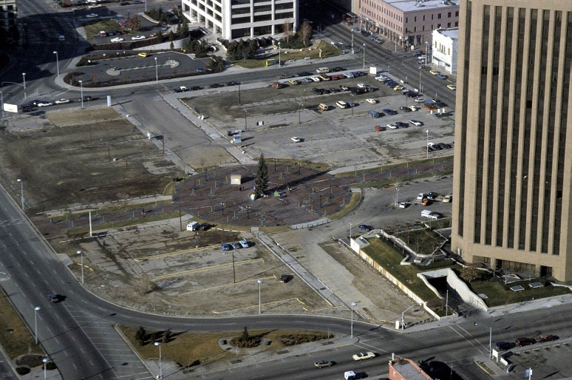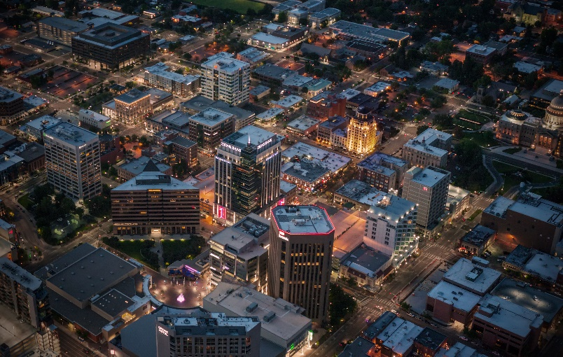
Idaho’s urban renewal statues provide local governments with tools and financial resources that were essential for downtown Boise’s remarkable redevelopment success. All of these developments benefitted from the Central District.
- City Center Plaza: Clearwater Analytics building, Main Street Station underground transit center, Boise Centre East – convention center expansion  - Renovations: Boise City National Bank building, The Mode building, Key Financial Center, The Idaho building, The Broadbent building, US Bank tower, The Grove Plaza  - 8th Street, Streetscapes, Utilities, Trees, Benches, Sidewalks, Street Lighting, Remediation, Stormwater | - The Wells Fargo Center & underground parking garage  - Main + Marketplace and Capitol & Main parking garage  - The Grove Hotel, CenturyLink Arena, Capitol & Front underground parking garage  - The Grove Plaza  - Eighth & Main tower  - 9th & Main and 9th & Front parking garages
Capital City Development Corporation is Boise’s urban renewal agency, created by Boise City Council under the authority of Idaho State statutes. Urban renewal agencies invest public money in public infrastructure to stimulate private development and investment to revitalize targeted areas.

